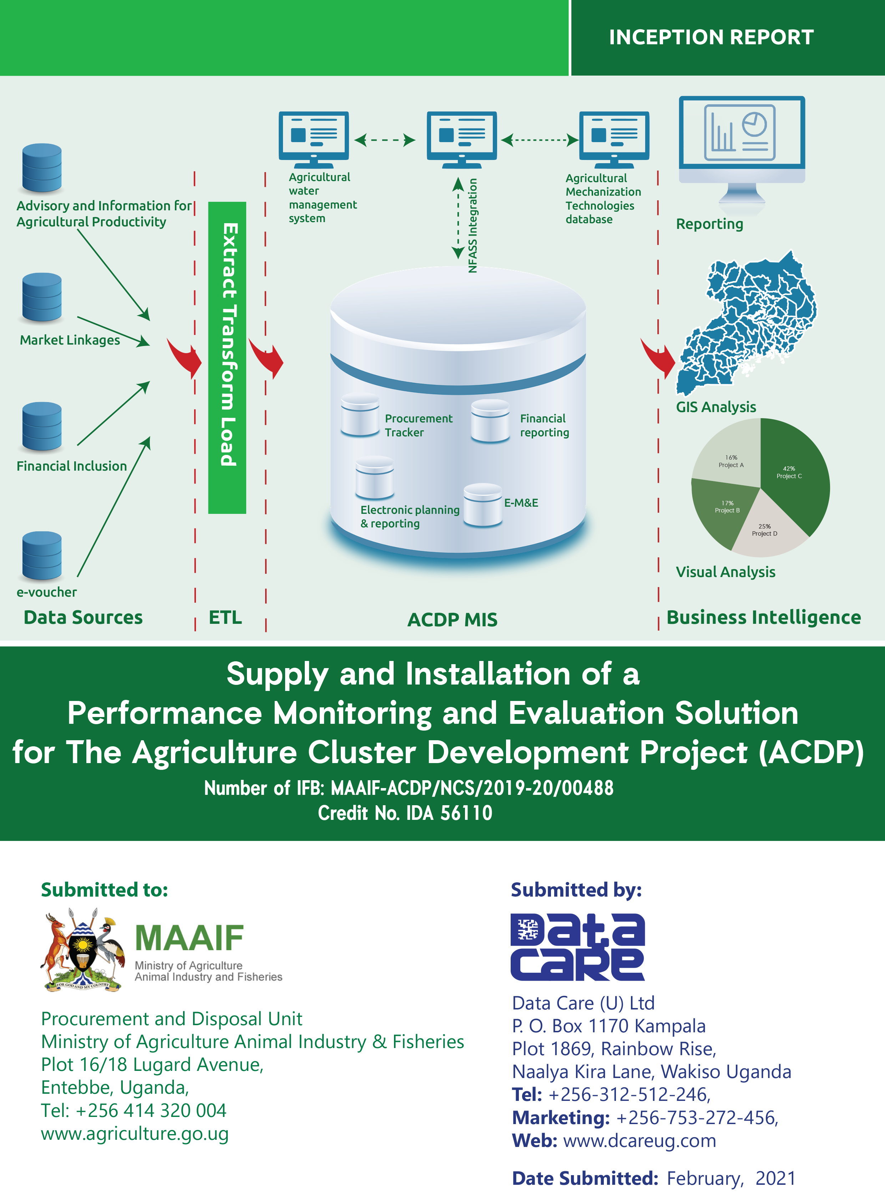

Document Version Control
Rev. No. | Rev. Date. | Rev. by | Rev. Description | Page No. | Action Taken | Comments
 | 22-02-21 | Data Care | Initial Version | - | Submitted | Awaiting feedback from ACDP and MAAIF

Table of Contents
Document Version Control i
List of Tables v
List of Figures vi
Acronyms vii
Executive Summary 2
1. Introduction and Background 3
2. Scope of work and understanding of the Assignment 5
3. The Agricultural Cluster Development Project (ACDP) MIS 6
3.1 Introduction to (ACDP) MIS 6
3.2 Problem Statement 6
3.3 Objective of the ACDP MIS 6
3.3.1 Specific Objectives of the ACDP MIS 6
3.4 ACDP MIS Scope of Work 7
3.4.1 Inception Phase 7
3.4.2 Development and Implementation phase 7
3.4.3 System Maintenance and operation Phase: 8
3.4.4 System Maintenance Phase 8
3.5 Deliverables / Outputs 8
3.5.1 Current system functionality 9
3.5.2 Gaps identified for Enhancement 9
3.6 ACDP MIS Development Process 11
4. The Agriculture Water Management Information System (AWMIS) 12
4.1 Introduction 12
4.2 Background 12
4.3 Objective for AWMIS 14
4.4 AWMIS Scope of Work 14
4.4.1 Inception Phase 14
4.4.2 Development and Implementation phase 15
4.4.3 System Maintenance and operation Phase: 15
4.5 Deliverables / Outputs 16
4.6 AWMIS Development Process 17
5. The Agriculture Mechanization Technologies Information System (AMTIS) 18
5.1 Introduction 18
5.2 Background 18
5.3 Objective of AMTIS 19
5.4 AMTIS Scope of Work 20
5.4.1 Inception Phase 20
5.4.2 Development and Implementation phase 20
5.4.3 System Maintenance Phase: 21
5.5 Deliverables / Outputs 21
5.6 AMTIS Development Process 22
6. The National Food and Agricultural Statistics System (NFASS) Database 23
6.1 Introduction 23
6.2 Background 23
6.3 NFAAS Scope of Work 25
6.3.1 Inception Phase 25
6.3.2 Database Development and Deployment 25
6.3.3 Validation and Training 26
6.3.4 Database Technical Support, Maintenance and Handover 27
6.4 NFASS Database Development Process 28
7. Development Approach/Methodology 29
Phase 1: Inception Phase 30
Phase 2: System Requirements Gathering & Specification 30
Phase 3: Design and Development of the Management Information Systems 31
Phase 4: Documentation 34
Phase 5: System Deployment, Maintenance and Handover 34
Phase 6: Technical Support and Training 35
8. Project Organization and Management Plan 37
8.1 Project Deliverables 37
8.2 Project Schedule 39
8.3 Process of orders acceptance 42
8.4 Product Testing & System Quality Assurance 42
8.4.1 Product Testing 42
8.4.2 System Quality Assurance 42
8.5 System Development Risk Mitigation 43
8.6 Risk management 43
8.7 Project Assumptions 45
8.8 Change Management. 45
8.9 Project Documents 47
8.10 Project Resource Matrix/Team Composition 48
8.11 Reporting and Feedback 51
9. Technical Support Plan 52
9.1 Technical Support Period 52
9.2 Support Desk Availability 52
9.3 Support Case Management 52
9.4 Logging a Support Request 52
9.5 Response time for Severity Levels 53
9.6 Case handling and resolution processes 54
9.7 Addressing software defects 54
9.8 Closing a Case 55
10. Pre-Commissioning and Operational Acceptance Testing Plan 56
10.1 Approach 56
10.1.1 Develop tests 56
10.1.2 Prepare to test 56
10.1.3 Run tests 56
10.1.4 Review Test Results 56
10.2 Change Management 57
10.3 Suspension Criteria and Resumption Requirements 57
10.4 Test deliverables 57
10.5 10.5 Responsibilities 57
11. Inception Report Approval 58

List of Tables
Table 1: Project Activities and Deliverables 36
Table 2: Phases, tasks, and the estimated duration and time of start 38
Table 3: Process of orders acceptance 41
Table 4: Project Risks, Probability of occurrence and Mitigation measures 43
Table 5: Project Assumptions 44
Table 6: Project Documents and delivery schedule 45
Table 7: Project Implementation Team 46
Table 8: Customer Support Contact Details 50
Table 9: Case Severity 51
Table 10: Case Status Values 52
Table 11: Software Defect Rectification Targets 53
Table 12: Features tested 56
Table 13: Features not tested 56
Table 14: UAT Team responsibilities 56
Table 15: UAT Acceptance Criteria 56

List of Figures
Figure 1: Project Scope 4
Figure 2: ACDP MIS Development Process 11
Figure 3: AWMIS Development Process 17
Figure 4: AWMIS Development Process 22
Figure 5: NFASS Database Development Process 28
Figure 6: Management process – PDCA 29
Figure 7: The AGILE Methodology 29
Figure 8: Development Cycle in AGILE 32

Acronyms
ACDP Agricultural Cluster Development Project
AMTIS Agriculture Mechanization Technologies Information System
API Application Programming Interface
ASSP Agriculture Sector Strategic Plan
AWMIS Agriculture Water Management Information System
BI Business Intelligence
DAIMWAP Department of Agricultural Infrastructure, Mechanization and Water for Agricultural Production
DAT Disruptive Agricultural Technological
EEA Enabling Environment for Agriculture Activity
ERP Enterprise Resource Planner
ETL Extraction, Transformation and Loading
GIS Geographical Information Systems
GOU Government of Uganda
HW Hardware
ISO International Standards Organization
MAAIF Ministry of Agriculture, Animal Industry, and Fisheries
MDAs Ministries, Departments and Agencies
MIS Management Information System
NADC National Agricultural Data Centre
NIMP National Irrigation Master Plan
NFASS National Food and Agricultural Statistics System
ODK Open Data Kit
PAD Project Appraisal Document
PDCA Plan-Do-Check-Act
PROMISE Program Management Information System
QMS Quality Management System
RAADRS Routine Agricultural Administrative Data Reporting System
RMT Routine Monitoring Tool
SoPs Standard Operating Procedures
SRS System Requirements Specifications
SW Software
ToR Terms of Reference
UAT User Acceptance Test
UBA United Bank for Africa
UGiFT Uganda Intergovernmental Fiscal Transfers Program

WBS Work Breakdown Structure

Executive Summary
The Agricultural Cluster Development Project (ACDP) is an initiative of the Government of Uganda, which is being implemented through the Ministry of Agriculture, Animal Industry and Fisheries (MAAIF). The project is designed to leverage digital and disruptive Agricultural Technologies, delivering agricultural services to farmers. The project has met various challenges such as delays in the development of the applications and system failures which has affected farmer group registration, farmer enrolments, farmer access to project information and agricultural extension, project implementation and monitoring, and data analytics in the implementation. To address the challenges, MAAIF and project team conducted a Disruptive Agricultural Technological (DAT) Innovation Challenge to identify technological applications to turn around the project performance, through automation of key business processes along the value chain, as well as improving service delivery to the intended project beneficiaries.

The implementation challenges were categorized into four areas, namely;
1. Advisory and Information for agricultural productivity
2. Market Linkages
3. Financial Inclusion
4. Data Analytics.
Data Care emerged winners in the Data Analytics category and was awarded a contract to develop Management Information Systems for the ACDP project.

This consultancy will undertake the development of the data analytics function which will be delivered as four different Management Information Systems namely:
- Agricultural Cluster Development Project Management Information System (ACDP MIS)
- Agriculture Water Management Information System (AWMIS)
- Agriculture Mechanization Technologies Information System (AMTIS)
- National Food and Agricultural Statistics System (NFASS) support.

The Deliverables of the project shall include
  - An inception Report
  - A Systems Requirements Specifications (SRS) Document/Report
  - An enhanced application / Functional System
    - System Architecture design report
    - User Acceptance Test (UAT) Report
  - Documentation
    - User manual for the front end of the system
    - Technical manual for the backend of the system
  - Training plan/report
  - Monthly progress reports
  - Project Closure report
  - Post implementation support

The consultancy is expected to be completed in a period of 17 weeks within which all the four fully designed Management Information Systems shall be installed and commissioned at the Ministry of Agriculture, Animal Industry and Fisheries (MAAIF) offices. This report details Data Care’s understanding of the assignment, implementation approach and Methodology and the Project Organization and Management Plan, and the detailed Work plan for the assignment.

1. Introduction and Background
The Government of Uganda (GOU), through the Ministry of Agriculture, Animal Industry and Fisheries (MAAIF) received funding from the World Bank towards the cost of the Agriculture Cluster Development Project (ACDP). The project objective is to raise on-farm production, productivity, and marketable volumes of Beans, Rice, Maize, Cassava and Coffee, in 12 geographical clusters, making up 55 districts. The ACDP is uniquely designed to leverage digital and disruptive Agricultural Technologies, delivering agricultural services to farmers including; input subsidies, extension, market information, and others through innovations such as e-vouchers, e-wallet, e-extension, e-diary, e-statistics and Management Information Systems (MIS).

In partnership with the World Bank, MAAIF organized a Disruptive Agricultural Technologies (DATs) Innovation challenge, in which agri-tech firms with proven agricultural digital solutions were invited to express interest in showcasing their innovative solutions that could mitigate implementation challenges of the ACDP. The objective of the Innovation Challenge was to explore opportunities offered by DATs to address the ACDP implementation challenges. The implementation challenges were categorized into four major categories, namely; (1) Advisory and Information for agricultural productivity, (2) Market Linkages, (3) Financial Inclusion, and (4) Data Analytics. Data Care emerged winners in the Data Analytics category that was held on 19/11/2019.

As part of fulfilment of the requirements for this assignment Data Care will develop (4) Management Information Systems namely:
- Agricultural Cluster Development Project Management Information System (ACDP MIS)
  - M&E – Planning and Reporting
  - Agriculture Water Management Information System (AWMIS)
  - Agriculture Mechanization Technologies Information System (AMTIS)
  - Administration – Procurement & FM (should be linked to planning under M&E)
- National Food and Agricultural Statistics System (NFASS)

2. Scope of work and understanding of the Assignment
To address one of the challenges of implementation of the ACDP specifically Data Analytics, Data Care will develop the following systems.
- Agricultural Cluster Development Project Management Information System (ACDP MIS)
- Agriculture Water Management Information System (AWMIS)
- Agriculture Mechanization Technologies Information System (AMTIS)
- National Food and Agricultural Statistics System (NFASS)
The linkages between the systems and our general understanding of the assignment are captured in the conceptual diagram below:
Figure 1: Project Scope

3. The Agricultural Cluster Development Project (ACDP) MIS

Introduction to (ACDP) MIS
This section details the work involved in the development of the ACDP MIS. It describes Data Care’s understanding of the assignment including its objective and scope. It further provides a schedule of the planned activities to complete the task.

Problem Statement
The ACDP has met various challenges in the implementation such as: delays in the development of the applications and system failures which has affected farmer group registration, farmer enrolments, farmer access to project information and agricultural extension, project implementation and monitoring, and data analytics. These challenges have slowed the progress of the project towards the realization of the development objective. It is envisioned that interventions such as DAT Innovation Challenge, could help MAAIF and project team to identify technological applications to turn around the project performance, through automation of key business processes along the value chain, as well as improving service delivery to the intended project beneficiaries.

Objective of the ACDP MIS
The main objective of the requirement is to enhance the functionality of the existing solution as presented by Data Care at the proof of concept workshop, by bridging the identified gaps to offer an all-inclusive Performance Monitoring and Evaluation System that will facilitate the delivery of the project.

3.3.1 Specific Objectives of the ACDP MIS
- To deliver the ACDP MIS, fully integrated with M&E, enhance the System to address the gaps identified at the proof of concept workshop, highlighted under scope of assignment in this document, and present a comprehensive application.
- To provide user training and requisite operational manuals for the system.
- Provide technical support and maintenance of the platform for a specified period of two years as highlighted under the list of deliverables.

ACDP MIS Scope of Work
Data Care will be responsible for the implementation of the ACDP MIS by providing all current functions of the MIS as captured in section 1.5.1 and addressing the gaps identified as captured in section 1.5.2 to provide an enhanced broader solution will be delivered in four phases namely the inception phase, Development and Implementation phase and System maintenance phase.

3.4.1 Inception Phase
During this phase, Data Care shall review the National Irrigation Master Plan and Agriculture Sector Strategic Plan (ASSP), as part of the requirements gathering activity where existing data will be identified and compiled.

Further field trips to carry out specific data collection will be carried out. This inception phase shall include an inception meeting with relevant stakeholders where Data Care presents their understanding of the assignment and also provide the following documentation / Information;
- Data collection plan including a review of data collection tools. Data to be collected shall be limited to only Agriculture infrastructure with a water for production component. Such infrastructure includes irrigation schemes, multi-purpose dams, and other infrastructure identified during literature review.
- System design and architecture,
- System components,
- Hard ware and Software requirements,
- System Requirement Specifications (SRS)
- System performance and monitoring measurable indicators and plan
- Cloud hosting requirements specific to the (NITA–U) Cloud Services
- Project implementation plan,
- System testing plan and optimization requirements
- Budget requirements.

3.4.2 Development and Implementation phase
This phase shall include development of the system dashboard, thematic databases for the different components and development of the web-service. Using the implementation plan, software frameworks agreed to during the inception phase, Data Care shall independently develop a prototype which will be tested. The steps to be undertaken during system development include;
- System development
- Database development
- System testing: Using the UAT plan agreed upon during the inception phase, Data Care and relevant ACDP and MAAIF staff- DAIMWAP will carry out user acceptance testing. Data Care shall address the changes as recommended and ACDP notified upon completion of this step.
- Data migration: ACDP and MAAIF shall together with Data Care agree on the datasets to be uploaded into the system and their thematic areas.
- System installation/deployment
- Institutional Capacity building: Data Care shall conduct a series of trainings to enable ACDP, MAAIF staff- DAIMWAP and district officials to fully use and maintain the system
NOTE:
- Security testing must be performed for all applications developed and any issues identified addressed before go live.
- The source codes of all applications developed must be transferred to MAAIF or transferred to the MAAIF repository operated by NITA

3.4.3 System Maintenance and operation Phase:
During this phase, Data Care will supervise the use and regular updating of content for the system, fixing of bugs, incorporation of minor changes and provide trouble shooting solutions when needed for a period up to 1 year.
This will include on-the-job support and handholding (including in-person, telephone and on-line support), as well as formal courses at regular intervals throughout this contract. Support and maintenance will be done after the system sign off.

3.4.4 System Maintenance Phase
During this phase, Data Care will supervise the use and regular updating of content for the system, fixing of bugs, incorporation of minor changes and provide trouble shooting solutions when needed for a period up to 2 years. This will include on-the-job support and handholding (including in-person, telephone and on-line support), as well as formal courses at regular intervals throughout this assignment.

3.5 Deliverables / Outputs
- Inception report showing the proposed methodology, a detailed work plan and development schedule.
- Operational web-based ACDP MIS for visualization of spatial distribution of project data and information.
- Imported data for all the different implementing partner databases.
- User Acceptance report
- Trained system users.
- System User manuals.

3.5.1 Current system functionality
The current functionality of the system is highlighted below;
The solution has an API to allow collection of data using the 3rd party data collection applications
- System is able to mine data from other applications
- The system is customizable to any requirement from the user
- User able to create their own analysis formulas
- Able to create own data collection tools
- System can pick point data to allow plotting within the system using the national polygon data
- System allows for manipulation of data to give user specific reporting requirements
- System has a workflow model that portrays a data journey through which the responsible officers authenticate the various levels along the journey

3.5.2 Gaps identified for Enhancement
The gaps identified for enhancement are highlighted below;
- Develop an overall e-Management Information System for the project
- Development of data collection tools required to aggregate data on project performance across components
- Improvement of existing data collection tools including customization of the tools to address emerging and specific data needs
- Support development of an e-M&E Management Information System (e-M&E MIS) that enables electronic planning and reporting (annual, quarterly and monthly) at the district and national level
- Provide for integration with any data collection systems within the project and Ministry; storage and management of the data that is parsed from the system(s).
- The e-MIS should cater for component functionalities in the project including tracking of procurements, financial reporting, communication.
- Administration component that eases tracking of day to day activities of the project such as activity scheduling, vehicle allocations for field activities, requisition for resources, assets and inventory management, records keeping, etc
- Store and visualize GIS data. The functionality should allow for (i) GIS data management (Database and interactive Visualization), (ii) Ability to upload shapefiles and rasters, (iii) ability to consume already provided map services, (iv) Ability to export and download GIS data and GIS products in PDF format
- Develop a resource center for project knowledge management for example storage of project reports
- Under matching grants have a platform for e-application, approval and management of matching grants
- The solution should have the ability for querying, filtering and analysis based on specified variables and produce the required reports as may be specified by the user
- The system should support aggregation of routine monitoring data and ability to download the data and manipulate it outside the system.
- Present a dash board of key project performance indicators in line with the project results framework. Automate measuring of progress made against the set targets on a periodic basis.
- Smooth flow of data from the data generators through the systems and cleaned for the necessary uploads.
- The Project MIS should cater for e-applications requirements for all project components
- Activities should be initiated through the system to ease performance tracking

ACDP MIS Development Process
The figure below (Figure 2) represents the conceptual flow of activities in the implementation ACDP MIS, outputs at each level and responsibility centres.

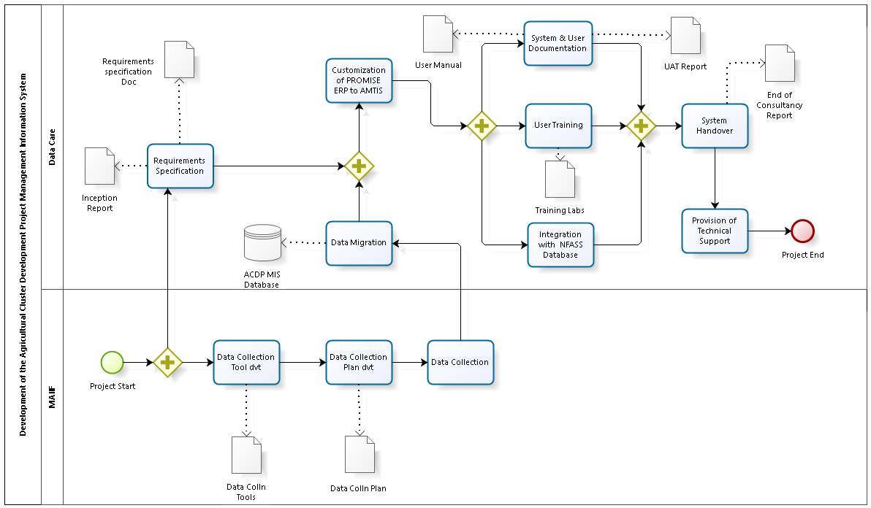
Figure 2: ACDP MIS Development Process

4. The Agriculture Water Management Information System (AWMIS)

Introduction
This section details the work involved in the development of the AWMIS. It describes Data Care’s understanding of the assignment including its objective for AWMIS and scope. It further provides a schedule of the planned activities to complete the task.

Background
According to MAAIF, Agriculture is of strategic importance to the Ugandan economy, contributing about 25% of the country’s annual GDP and providing livelihoods for almost 75% of its working population. The agricultural sector is fragmented and dominated by small holder farmers most of whom combine subsistence farming with cash crop and livestock farming. Although Uganda is able to rely on agriculture due to the country's excellent access to waterways, fertile soils, and the two seasons of rainfall, the country suffers from intermittent droughts. With increasingly unpredictable rainfall and more frequent prolonged dry spells, the result is a reduction in total agricultural production.
The Ministry of Agriculture, Animal Industry and Fisheries (MAAIF) together with the Ministry of Water and Environment (MWE) jointly developed a National Irrigation Policy aiming at promoting irrigated agriculture, increasing efficient water use in irrigation and contributing to agricultural production and productivity.

Currently, the Government is in the process of developing a comprehensive National Irrigation Master Plan (NIMP) as a long-term plan that will guide irrigation planning and provide a strategic framework for prioritized investments for development of irrigation infrastructure to be technically feasible, economically viable, socially desirable and environmentally sustainable.

Uganda’s Vision 2040 mentions total irrigated area in Uganda to be approximately 14,500 ha (3.6%) of the total irrigable area which is estimated at 420,000 ha. The estimate for irrigable area has since been changing with the latest estimate by the Nile Basin Initiative at 3,000,000 ha. After field investigations and review of the available literature, this estimation will be confirmed.

Also, of the estimated 14,500 ha, commercial plantations occupy about 5,300 ha (36.6%) leaving the rest being shared between the 5 government irrigation schemes of Mubuku Irrigation Settlement Scheme (516 ha), Doho Rice Scheme (830 ha), Olweny Swamp Irrigation Scheme (500 ha), Agoro (13 ha), Kiige (60 ha), plus small-scale irrigation (300 ha). The current status of each scheme, actual crop yields compared to potential and research yields, management and extension system in every scheme should be established during field visits.

During the preparation of the National Irrigation Master Plan (NIMP), existing irrigation schemes and areas with irrigation potential will be identified and all their attribute information defined.

The preparation of the NIMP recommends development of an irrigation MIS where all this information such as irrigation coverage will be organized for access and decision making. In addition, the NIMP recommends incorporation of geographic locations of farmers, irrigation schemes, their water demand/use, available water at different locations of the river reaches to facilitate irrigation scheduling, market centers, among others. Such an MIS is envisaged to provide valuable information to evaluate water use efficiency for increased productivity, evaluation of success or failure of irrigation schemes/activities in Uganda.

Currently agriculture water data is scattered in different documents and also across different databases in different software, formats, and maintained by different agencies.

At the same time, operationalizing water use regulation through water rights and water permits requires data that is better managed in an information management system. Designing of a distribution management system with procedures for routine use, irrigation scheduling, water rights, water allocation, water availability is key for proper farmer managed irrigation systems. This requires water balance studies; however these are outside the scope of this exercise given budget limitations.
Geographical Information systems (GIS) have been identified as a suitable option to organize and display water management information analysis, planning and decision making. A GIS aided system will enable integration of multi sectoral data such as climate data, water use data, soil data among others and provides a basis for establishment of spatial relationships, distribution and prioritization of future infrastructure investments. In addition, use of remote sensing data is increasingly becoming the most suitable option for obtaining information such as cropping pattern, planting and harvest time, irrigation coverage, area under irrigation and this needs to be incorporated.

The Ministry of Agriculture, Animal Industry and Fisheries (MAAIF), through the Agriculture Cluster Development Project (ACDP) wishes to develop a GIS web based Agriculture Water Management Information System (AWMIS) as a component of the overall integrated web-based Agricultural Management Information System (AMIS).
Among the ministry’s expected outputs is the establishment of sustainable systems to collect, process, maintain and disseminate agricultural statistics.

It is against this background that MAAIF, through ACDP sought the consultancy services of Data Care Uganda Limited to develop an Agriculture Water Management Information System (AWMIS).

Objective for AWMIS
The main objective of this consultancy is to design and develop a web-based Agriculture Water Management Information System (AWMIS) that will provide a platform for visualization of spatial distribution of Agriculture water data and information thereby improving service delivery through timely provision of accurate, well- organized data, to support evidence based decision making by various stakeholders.

AWMIS Scope of Work
The scope of this consultancy is divided into three phases, namely the inception Phase, Development Phase and Maintenance Phase as shown below.

4.4.1 Inception Phase
During this phase, Data Care shall review existing literature on Agriculture Water for production including the National Irrigation Master Plan and Agriculture Sector Strategic Plan (ASSP), as part of the requirements gathering activity where existing data will be identified and compiled.

Further field trips to carry out specific data collection will be carried out. This inception phase shall include an inception meeting with relevant stakeholders where Data Care presents their understanding of the assignment and also provide the following documentation / Information;
- Data collection plan including a review of data collection tools. Data to be collected shall be limited to only Agriculture infrastructure with a water for production component. Such infrastructure includes irrigation schemes, multi-purpose dams, and other infrastructure identified during literature review.
- System design and architecture,
- Content management system,
- System components,
- Hard ware and Software requirements,
- System Requirement Specifications (SRS)
- System performance and monitoring measurable indicators and plan
- Cloud hosting requirements specific to the (NITA–U) Cloud Services
- Project implementation plan,
- System testing plan and optimization requirements
- Budget requirements.

4.4.2 Development and Implementation phase
This phase shall include development of the system dashboard, thematic databases for the different components and development of the web-service. Using the implementation plan, software frameworks agreed to during the inception phase, Data Care shall independently develop a prototype which will be tested. The steps to be undertaken during system development include;
- System development
- Database development
- System testing: Using the UAT plan agreed upon during the inception phase, Data Care and relevant ACDP and MAAIF staff- DAIMWAP will carry out user acceptance testing. Data Care shall address the changes as recommended and ACDP notified upon completion of this step.
- Data migration. ACDP and MAAIF shall together with Data Care agree on the datasets to be uploaded into the system and their thematic areas.
- System installation/deployment
- Institutional Capacity building: Data Care shall conduct a series of trainings to enable ACDP, MAAIF staff- DAIMWAP and district officials to fully use and maintain the system

4.4.3 System Maintenance and operation Phase:
During this phase, Data Care will supervise the use and regular updating of content for the system, fixing of bugs, incorporation of minor changes and provide trouble shooting solutions when needed for a period up to 1 year. This will include on-the-job support and handholding (including in-person, telephone and on-line support), as well as formal courses at regular intervals throughout this contract. Support and maintenance will be done after the system sign off.

4.4.4 System Maintenance Phase
During this phase, Data Care will supervise the use and regular updating of content for the system, fixing of bugs, incorporation of minor changes and provide trouble shooting solutions when needed for a period up to 2 years.
This will include on-the-job support and handholding (including in-person, telephone and on-line support), as well as formal courses at regular intervals throughout this assignment.

Deliverables / Outputs
- Inception report showing the proposed methodology, a detailed work plan and development schedule.
- Operational web-based AWMIS for visualization of spatial distribution of Agriculture water data and information.
- Imported data for all the different implementing partner databases.
- User Acceptance report
- Trained system users.
- System User manuals.

AWMIS Development Process
The figure below represents the conceptual flow of activities in the implementation AWMIS, outputs at each level and responsibility centres.
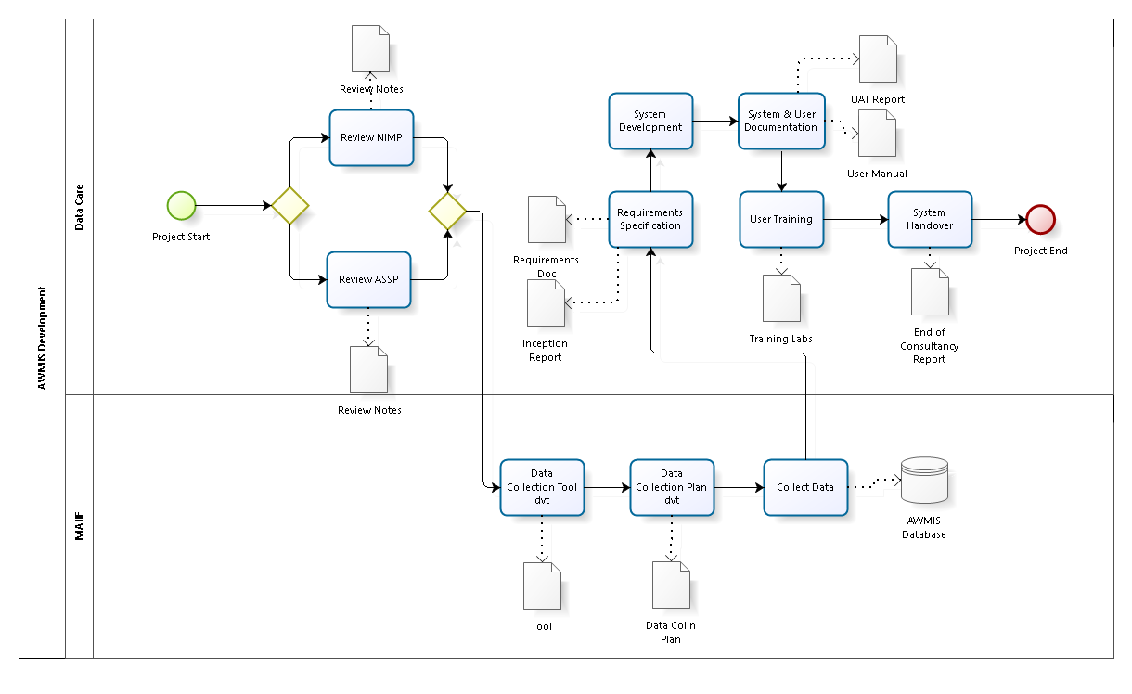
Figure 3: AWMIS Development Process

The Agriculture Mechanization Technologies Information System (AMTIS)

Introduction
This section details the work involved in the development of the AMTIS. It describes Data Care’s understanding of the assignment including its objective and scope.

Background
Agriculture is one of the five strategic sectors, identified by the National Development Plan (NDP II) that will transform Uganda’s economy from low to middle income status. The Agricultural Sector employs about 72 percent of the total labour force (including the disguised labour), 77% of whom are women and 63% are youth most of whom reside in rural areas (Statistical Abstract, 2017).

With limited agricultural Mechanization, the sector accounted for 24.9% of the total GDP in the FY 2016/17 and the Agricultural exports accounted for 40% of total exports in 2014/15. Agriculture has a catalytic effect on other sectors and has capacity to play a critical role towards reduction of extreme poverty and hunger by sustainably intensifying production.

The Investment Plan (DSIP) of the Ministry of Agriculture Animal Industries and Fisheries (MAAIF) gives priority to commercialization of the agriculture sector through development of commodity value chains.

The Agricultural Sector Strategic Plan (ASSP) 2015/16 -2019/20, priority 2 focuses on increasing access to critical inputs. The Ministry identified promotion of agricultural mechanization as a strategic intervention area. UBOS 2017 indicates that 43.2% (6.0 million) of the working population in Uganda is under subsistence agriculture characterized mostly by small holdings with farming system managed by small scale farmers who cultivate less than two hectares of land.

The preliminary survey that informed the 2014 Sector Plan and Investment Strategy pointed out that, over 90% of the farm production-to-market transactions are done using rudimentary, inefficient and labour intensive hand tools with household labour, 8% manage to use animal traction, and less than 2% can afford the use of tractors for basic farming. In the emerging production system tractors and their implements are critical for land preparation, planting, weeding, harvesting, and water pumping among many other applications.

The application of farm power to appropriate tools, and implements (farm mechanization) is essential due to the following reasons;
- Improves the timeliness and efficiency of farm operations leading to cost savings and increased yields;
- It reduces drudgery in farming activities thereby enhancing lifestyles and
- It provides employment opportunities in communities and can lead to agriculture-led
- It has potential to address the problem of shortage of labour arising from high rural-urban migration of able-bodied persons

Agricultural mechanization information interacts with and influences agricultural productivity in a variety of ways. It can help inform decisions regarding land, labour, livestock, capital and management. Using this data, information systems can be developed to disseminate information to farmers and high-level decision makers so that better decisions can be made so that farmers may take advantage of market opportunities and manage continuous changes in their production systems.

The Ministry of Agriculture, Animal Industry and Fisheries (MAAIF), through the Agriculture Cluster Development Project (ACDP) wishes to develop a web based Agriculture Mechanization Information System (AMTIS) as a component of the overall integrated web-based Agricultural Management Information System (AMIS). Among the ministry’s expected outputs is the establishment of sustainable systems to collect, process, maintain and disseminate agricultural statistics.

It is against this background that MAAIF, through ACDP sought the consultancy services of Data Care Uganda Limited to develop an Agriculture Mechanization Information System (AMTIS).

Objective of AMTIS
The main objective of the assignment is to design and develop a web based Information Management System for Mechanization Technologies under the Ministry of Agriculture that will act as a registry, inventory and assist the division in tracking implementation, and measuring effectiveness of the sector interventions in increasing access, utilization and adoption of Agricultural Mechanization Technologies (AMTs).
This will provide an opportunity to management to obtain information and measure performance of different players in Mechanization against targets in real time.

AMTIS Scope of Work
The scope of this consultancy is divided into three phases, namely the Inception Phase, Development and Implementation Phase, System Maintenance Phase as shown below.

5.4.1 Inception Phase
During this phase, data collection forms will be developed by ACDP / MAAIF to facilitate field trips to collect specific relevant data. The inception phase shall also include an inception meeting with relevant stakeholders to clarify the project objectives, strategy and implementation. During this meeting, Data Care presents their understanding of the assignment and also provide the following documentation/ Information;
- Data collection plan including a review of data collection tools.
- System design and architecture,
- Content management system,
- System components,
- Hard ware and Software requirements,
- System Requirement Specifications (SRS)
- System performance and monitoring measurable indicators and plan
- Cloud hosting requirements specific to the (NITA–U) Cloud Services
- Project implementation plan,
- System testing plan and optimization requirements
- Budget requirements.

5.4.2 Development and Implementation phase
This phase shall include development of the system dashboard, thematic databases for the different components and development of the web-service. Using the implementation plan, software frameworks agreed to during the inception phase, Data Care shall independently develop a prototype which will be tested. The steps to be undertaken during system development include;
- System development
- Database development
- System testing: Using the UT plan agreed upon during the inception phase, Data Care and relevant ACDP and MAAIF staff- DAIMWAP will carry out user acceptance testing. Data Care shall address the changes as recommended and ACDP notified upon completion of this step.
- Data migration. ACDP and MAAIF shall together with Data Care agree on the datasets to be uploaded into the system and their thematic areas.
- System installation/deployment
- Institutional Capacity building: Data Care shall conduct a series of trainings to enable ACDP, MAAIF staff- DAIMWAP and district officials to fully use and maintain the system.

5.4.3 System Maintenance Phase:
During this phase, Data Care will supervise the use and regular updating of content for the system, fixing of bugs, incorporation of minor changes and provide troubleshooting solutions when needed for a period up to 1 year.
This will include on-the-job support and handholding (including in-person, telephone and on-line support), as well as formal courses at regular intervals throughout this assignment. Support and maintenance will be done after the system sign off.

5.4.4 System Maintenance Phase
During this phase, Data Care will supervise the use and regular updating of content for the system, fixing of bugs, incorporation of minor changes and provide trouble shooting solutions when needed for a period up to 2 years. This will include on-the-job support and handholding (including in-person, telephone and on-line support), as well as formal courses at regular intervals throughout this assignment.

Deliverables / Outputs
- Inception report showing the proposed methodology, a detailed work plan and development schedule.
- Software requirements specification document describing what the system will do and the functionality that it needs to fulfill all stakeholders’ needs.
- Operational web-based AMTIS for visualization and analysis of relevant Mechanization technologies data.
- Imported data for all the different implementing partner databases.
- User Acceptance report
- Trained system users.
- System User manuals.

AMTIS Development Process
The figure below represents the conceptual flow of activities in the implementation AMTIS, outputs at each level and responsibility centres.
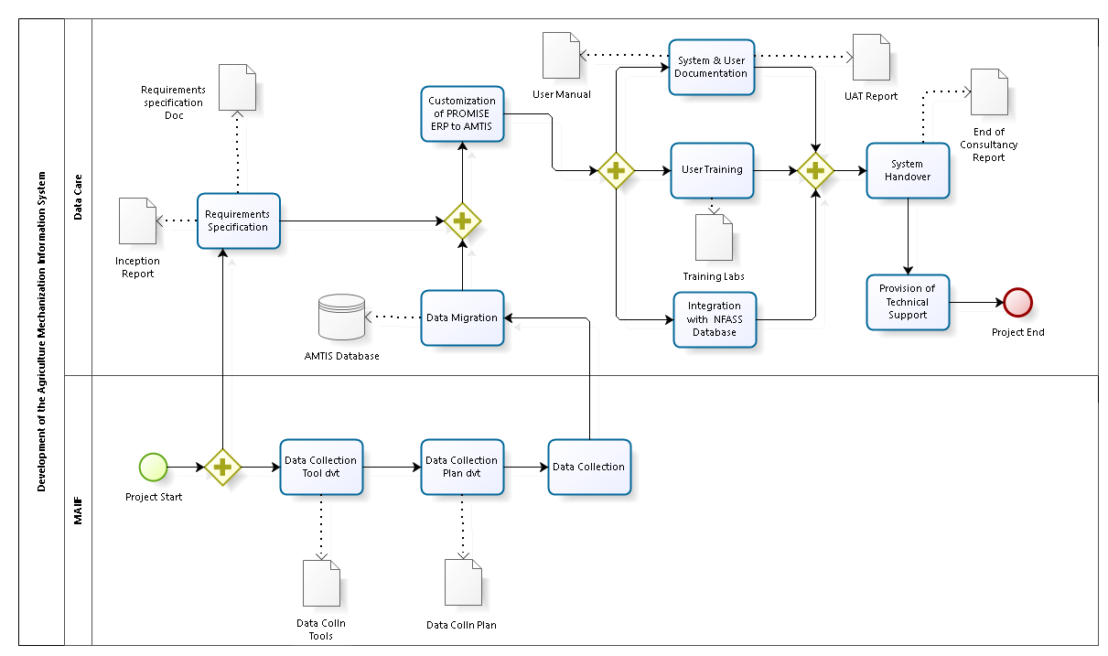
Figure 4: AWMIS Development Process

6. The National Food and Agricultural Statistics System (NFASS) Database

6.1 Introduction
This section details the work involved in the development of the NFASS database. It describes Data Care’s understanding of the assignment including its objective and scope. It further provides a schedule of the planned activities to complete the task.

Background
Agriculture has been and remains central to Uganda ‘s economic growth and poverty reduction. It employs about 72 percent of the working population (UBOS, 2015), is a major source of raw materials for the manufacturing sector, a market for non-agricultural outputs and a source of surplus for investment.

The importance of the agricultural sector demands that its planning, management, and monitoring be based on sound evidence. This, in turn, requires the sustained availability of comprehensive, reliable, up-to-date, and consistent statistical data. In addition, these data need to be in a form that renders them intelligible and usable for a variety of situations. Unfortunately, Uganda’s agricultural statistical systems and data are deficient - the systems are weak, uncoordinated, insufficiently resourced, and essentially unsustainable.

Further, the outputs from the agricultural statistics system require enhancement in terms of quantity, quality, and dissemination. Over the past years new and pressing data requirements have emerged which are necessary to inform policy on development issues such as food balance sheet, climate change and global warming, environment, and food security.

Within the National Statistical System, the Ministry of Agriculture, Animal Industry and Fisheries (MAAIF) and the Uganda Bureau of Statistics (UBOS) collaborate in data collection and production of statistics on key agricultural indicators. UBOS is responsible for conducting censuses and national surveys, while MAAIF is responsible for specialized surveys and collection of administrative data, management, implementation, monitoring and evaluation of agricultural related statistics.

The goal of the National Food and Agricultural Statistics System (NFASS) is to ensure that data related to the agricultural sector is accurate, timely, consistent, disaggregated and accessible to facilitate planning, monitoring and decision making in MAAIF and local governments as Uganda makes private sector investment decisions.

The NFASS has three integrated parts:
- A National Agricultural Data Centre (NADC)
- Routine Agricultural Administrative Data Reporting System (RAADRS) and
- Institutional Data module which provides linkage with Ministries, Departments and Agencies (MDAs).
The NADC is the central component for receiving, processing and disseminating data to users while the broader Institutional Network and the Agricultural Network provide data and receive processed information for use in decision-making and other purposes. The NADC component was established 2015 with support from EEA, which has helped to equip the centre with state-of-the art hardware and software.

Pivotal to the effective functioning of NADC is the need for a database that captures and stores all relevant agricultural data and enables analysis and generation of reports for various users. The database will sit at the core of NFASS. District and sub-county agricultural extension workers and MAAIF personnel will collect and input primary and administrative data into the database. To address the gaps in availability and use of credible agricultural statistics and in line with its mandate, MAAIF is establishing NFASS with initial support from Feed the Future Uganda, Enabling Environment for Agriculture Activity (EEA).

EEA is a seven-year project (April 2013 – April 2020) that aims to improve the enabling environment for agricultural development, trade and adaptation to climate change within the coffee, maize, and beans value chains. A specific objective of the project is to support and strengthen the capacity of the Government of Uganda (GOU) institutions to facilitate agricultural development and trade. As part of this, a goal of EEA is helping MAAIF to establish and operate a sustainable, effective and efficient system for collecting, managing, and analyzing agricultural statistics. Between July 2018 - November 2018, EEA hired Data Care to work with MAAIF to specify systems requirements and design a relational database for the sector.

The second phase in the process is database construction/development that is now being handled in this contract. It is envisaged that the third phase of maintenance of the database will be funded by the Agricultural Cluster Development Project (ACDP) of the World Bank, to ensure sustainability and continuity of the database after it is finalized.

NFAAS Scope of Work
Data Care will be responsible for development of the NFASS database. Data Care will work closely with MAAIF as the end-users to ensure their needs, input and concerns are being incorporated in the database design and final product. Data Care will utilize all approved plans, schematics, specifications, institutional history and knowledge, database design reports, documentation, etc. from the relational database phase described in the terms of reference.

Database design and development will occur in four phases as described below:

6.3.1 Inception Phase
- Reviewing project documents (User Requirements Specification report, System Architecture Design Report and other MAAIF documents) to inform system development.
- Hold an inception meeting with MAAIF’s technical team and EEA to agree on the development platforms, project execution methods (AGILE) and the product backlog with clear timelines and the definitions of done.
- As an outcome of the inception meeting, Data Care will develop a work plan with discrete tasks, timelines and points of contact.

6.3.2 Database Development and Deployment
- Design input interface mock-ups and output reports.
- Database creation, development of input screens, reports, and business rules including security, validations, etc.
- Implement unit tests based on the test cases developed.
- Deploy prototype(s) and functional test validation with project team.
- Conduct system improvements, taking into account feedback from the project team and other users.
- Implement security measures and performance.
- Develop Integration Interfaces (API) with systems in the environment/scope.
- Temporary deployment and realization of security and performance tests.
- Prepare draft development report exhibiting the work, programming standards, report on prototype validation, test results on security and performance in relation to the desired functionalities as per user requirements and systems requirements.
- Develop the database modeling phase and share the final choice of the database modeling toolsets, the installation of the online visual database design tool for MS SQL Server & MySQL setup
- Create and export standard SQL based on the master design template for shared Relational Schemas and Star Schemas or any other query creation options
- Creating the Extraction, Transformation and Loading (ETL) processes in the setup of the core data warehouse
- Install the content management system database component at the backend and the pilot sites
- Set-up of real-time data pipelines that enable the realization of the operational data store within MAAIF’s Data Center
- Draft online manuals to incorporate feedback into the final versions
- Test user understanding and possible usage of the systems features, components and outputs with sample sites
- Pilot test with the targeted users to ensure they are user-friendly. Sign-off on user experience issues that MAAIF needs to follow-up on during the system lifecycle (long-term aspects).
- Data conversion and migration

6.3.3 Validation and Training
- Develop training manuals, user manuals and system manuals. Incorporate comments and feedback to improve system documentation.
- Create a training plan and develop training content (user and administrator training manuals, agenda, handouts, exercises, slide decks, participant evaluation forms) to train MAAIF users and administrators on the system. Incorporate any feedback to ensure training content and delivery is user friendly
- Train system administrators and users tailoring sessions for each as appropriate
- Prepare a concise training report after the training is conducted.
- Embed context sensitive user help manual in the database.
- Enhance the database based on training feedback as needed.

6.3.4 Database Technical Support, Maintenance and Handover
This includes but is not limited to:
- Support system administrators and conduct follow-up training sessions for users as needed
- Provide remote technical support by email, phone or Skype
- Make minor system improvements as and when requested by MAAIF’s database point of contact
- Turnover to MAAIF the source code where applicable with inline documentation.
- Write a final development report and submit to EEA and MAAIF

NFASS Database Development Process
The figure below represents the conceptual flow of activities in the implementation NFASS Database, outputs at each level and responsibility centres.
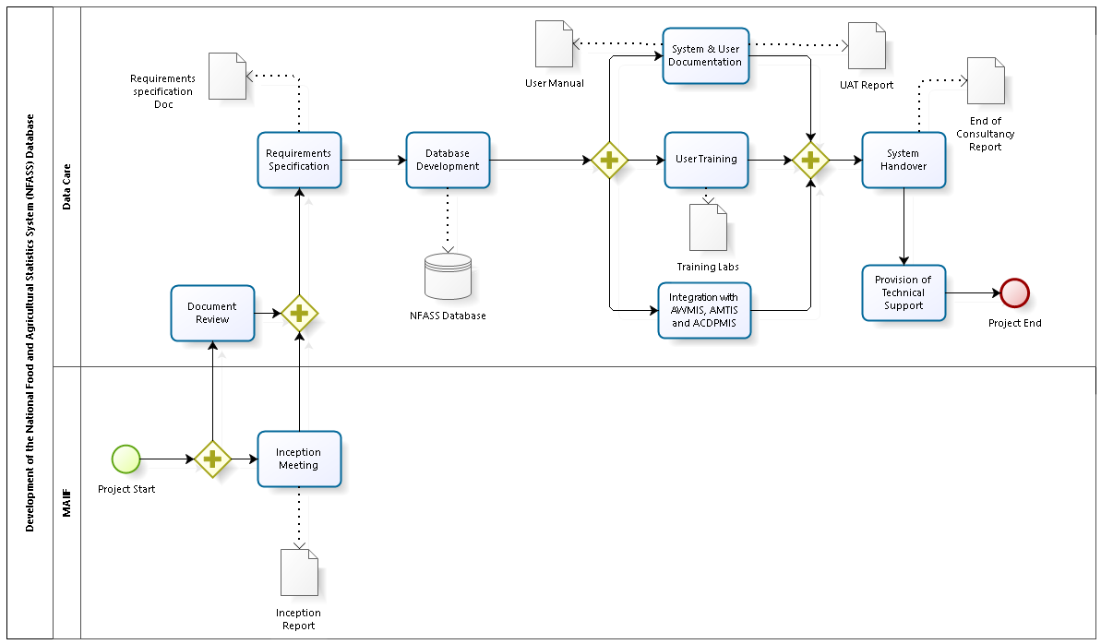
Figure 5: NFASS Database Development Process

7. Development Approach/Methodology
To meet the objectives of the project, Data Care will employ a HYBRID of AGILE and the Plan-Do-Check-Act (PDCA) approach towards the development of the e-Management Information System. As indicated in figure 3, the management process will employ the 4 phased approach of PDCA and will also adopt the AGILE methodology as indicated in figure 4 to be used to manage the project feedback and the database development up to the coding standards.
Figure 6: Management process – PDCA
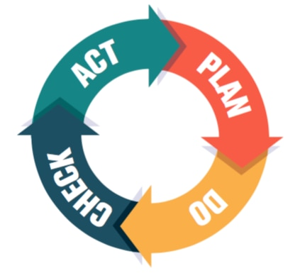

Figure 7: The AGILE Methodology
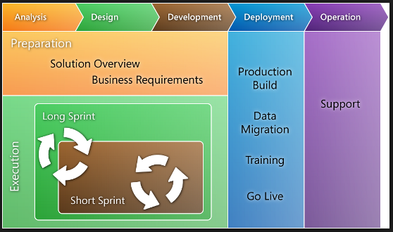

Based on the management process and the AGILE methodology shown above, the design of the e-Management Information System will involve engagement of the user departments to ensure that attention is paid to both the functional and non-functional requirements of the users. Stakeholder management will therefore be essential in ensuring that user needs are well documented by reviewing literature on project design, technical reports, approved plans, schematics, specifications, institutional history and knowledge and database design reports.

The design and development of the e-Management Information System will be carried out in 6 phases: -

Phase 1: Inception Phase
- Hold an inception meeting with the ACDP & MAAIF technical team including the Component Managers to better understand the scope of work, to review and update the requirements of the user departments, agree on the development platforms, reviewing project documents (User Requirements Specification report, System Architecture Design Report and other ACDP documents) to inform the development of the system.
- Reviewing the existing documents including the Agriculture Sector Strategic Plan (ASSP), Project Appraisal Document (PAD) and restructuring report, Project Implementation Manual, Report of Baseline survey for ACDP, Results Framework, annual targets indicators and monitoring tools for the various programmes, agencies and projects of the Ministry;
- Identifying and determining the key project stakeholders involved in data acquisition, processing, reporting, or use/decision making.
- Reviewing the descriptive document (concept notes, system requirements documents, others) to better understand the types of data and information products that will be incorporated into the database;
The inception phase will culminate with the writing and the submission of an inception report (deliverable) that will include the understanding of the assignment, the implementation methodology, the resource matrix, the schedule of the planned activities to complete the tasks, the project deliverables and the team composition.

Phase 2: System Requirements Gathering & Specification
- Determining the detailed system requirements including the components related to the M&E, Statistics, Administration and Management as well as GIS.
- Determining the detailed system performance and monitoring measurable indicators.
- Reviewing the existing systems (manual and automated) to determining how the integration will be carried out and the transition process to an integrated e-management system for all the project components.
- Reviewing the existing staff capacities, procedures, tools, and data processes
- Defining the hardware and software requirements that will support the development of the system

This phase will culminate with the writing and the submission of the System Requirements Specifications (SRS) Report. The SRS report will define all key aspects of Retooling (the system structure, indicators, report formats, information flow, internal and external system structure and hosting arrangements, additional hardware/software/ data/ connectivity requirements, institutional arrangements, etc.)

Phase 3: Design and Development of the Management Information Systems
The development phase will precede the approval of the inception report, updates of the scope of the work (including the functional and non-functional requirements), completion of the requirements gathering and submission of the SRSR. The system development backlog will be informed by the AGILE Development Lifecycle as shown in figure 5.

Figure 5 details the processes to be followed to produce a fully functional and accepted product. Weekly sprints will be done to review the tasks carried out by the team, the tasks to be carried out, any challenges the team is facing and suggested solutions upon approval of the inception report,

Data Care will prepare a system development backlog that will inform the development sequence (Figure 5) and the weekly sprints to be done and reported on. The weekly scrum/standup sessions will provide the sprint updates and any project blockers will be addressed in these sessions. The Bimonthly sessions, will be used as System release sessions and user involvement that involves a 4 step approach of continuously analyzing, designing, building and testing with a dedicated team to carry out product testing and quality assurance. The deployment of the product is therefore done in an agile process involving continuous iteration and testing activities throughout design and development lifecycle.
Figure 8: Development Cycle in AGILE
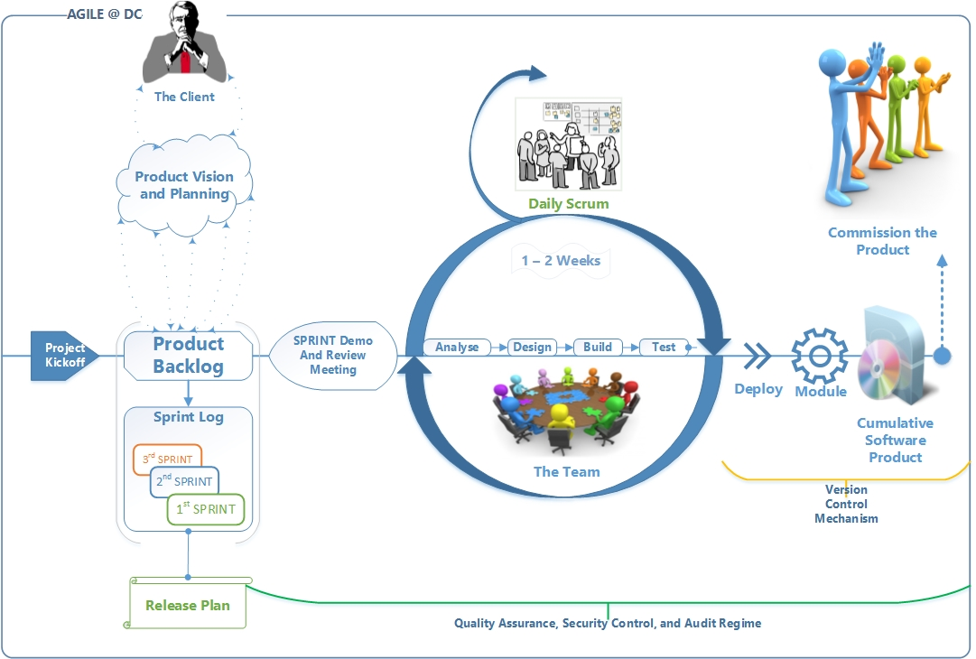

The design and the development activities will generally include the following: -
- Gathering and documentation of the project SoPs, the tabulation plans, data collection tools (manual), APIs to the existing systems and tools such as ODK, Kobo Collect as the project transitions to customized data collection tools.
- Designing of a system to accommodate data entry /collection using manual printed forms, mobile technologies and web based remote interfaces, and supporting real time transfer of data;
- Performing a systems analysis for design of query, form and report production from the system to meet the needs of all the ACDP components
- Preparing of automated report generation and associated queries using the appropriate identified software
- Conversion and migration of existing data, held in the existing databases and any other formats, for import into the new system, including field format conversions to extract information from text fields
- Carrying out quality assurance activities such as ensuring accurate inputting of data received from various sources and partners into the system
- Defining the optimization requirements for planned system to be able to handle hundreds of thousands of data forms for maximum performance
- Developing a User Acceptance Test (UAT) plan detailing scenarios and timelines
- Undertaking the development of the system conforming to the design report
- Conducting online bi-weekly standup sessions to review the progress indicating functionalities that have been implemented
- Designing input interface mock-ups and output reports
- Designing the prototype and developing the input screens, reports, and business rules including security, validations among others
- Implementing unit tests based on the test cases developed
- Deploying the prototype(s) and functional test validation with project team and presenting to the ACDP team.
- Conducting continuous system improvements, taking into account feedback from the project team and other users.
- Implementing security measures and performance throughout the project life-cycle
- Developing Integration Interfaces (API) with systems in the environment/scope
- Preparing draft development report exhibiting the work, programming standards, report on prototype validation, test results on security and performance in relation to the desired functionalities as per user requirements and systems requirements.
- Creating the Extraction, Transformation and Loading (ETL) processes in the setup of the core data warehouse
- Installing the content management system component at the backend and the pilot sites
- Set-up of real-time data pipelines that enable the realization of the operational data store within ACDP’s Data Center
- Carrying out pilot tests of the system to ensure there is consistency with the requirements of the user departments
- Conducting User Acceptance Testing(UAT) with ACDP and submitting a UAT report for approval
- Writing and submitting a system design report that will include but not limited to a general description of the system, the different pages or screens within the system including the different interfaces and connections within those pages, ways for data to be input, stored, analyzed and extracted, system redundancies.

Phase 4: Documentation
- Developing a documentation system (such as training manuals, user manuals and technical manuals) that will include the instructions for system use, maintenance, repairs, and upgrades
- Preparing bi-weekly minutes for progress meetings held by the teams
- Preparing bi-weekly briefs on project progress
- Preparing and submitting a training plan for approval
- Preparing a training report
- Preparing and submitting monthly progress reports to the Project Team.
- Preparing a System Development Report
- Preparing and submitting an End of Project Report

Phase 5: System Deployment, Maintenance and Handover
The deployment process for the system will take the form determining the resources required to ensure high performance and documentation of the actual deployment as well as preparation for other related hardware and software requirements. Data Care will therefore consider implementing the following activities in Phase 5.
- Documenting the maintenance and implementation process
- Documentation and approval of the maintenance review and acceptance process
- Establishing and documenting the required infrastructure including the licensing requirements
- Establishing the ACDP technical support team (the systems administrator, the database administrator, release coordinators and the focal persons) and planning for maintainer and user training
- Developing a maintenance plan
- Developing a transition plan (from Data Care to ACDP and from the manual to the automated processes)
- Creating user accounts and credentials
- Identifying the required items for the routine maintenance program and the back-up process
- Documenting the system programming standards and architectural patterns
- Submitting the installation process report to the ACDP technical team (include the minimum requirements for installation and maintenance)
- Submitting the test results on security and performance
- Data Conversion and Migration Processes
- Submitting a handover technical report to ACDP including the overview of main tasks, list of documentations, learning points, action points, recommendations and the next steps.
- Write a final development report and submit ACDP.

Phase 6: Technical Support and Training
This phase will be an on-going process through phase 1 to phase 5 and further for another 12 months as provided for in the ToR. Specific to this phase Data Care will be: -
- Developing both electronic and hard copy documentation for appropriately supporting and training the relevant stakeholders including hands-on training, on-job support, on-line support and development of training manuals.
- Carrying out all activities related to maintenance and support for 12 months detailed as: -
  - Provide Preventive Maintenance Activities
    - Performing periodic monitoring of Space, Resource, Capacity Planning, Application tuning, maintenance and code restructuring to improve the efficiency and/or reliability of the statistical database.
    - Recommending the tools to help identify areas where preventive maintenance might be performed to improve statistical database efficiency.
  - Troubleshooting at both application level and user level
  - Providing assistance to the ACDP focal persons on the operation of the portal
  - Fixing bugs focal official/client in operation of the portal;
  - Fixing of bugs, incorporation of minor changes and managing version tracking
  - System Upgrade to address any malfunctions in the system
    - Providing automation capabilities for common user requests
    - Enhancing the system to address the common issues being generated from user requests
    - Updating the Extraction, Transformation and Loading (ETL) processes as data sources get updated in structure at the agencies and Directorates
    - Upgrading the base system as and when the vendors (Microsoft and others) avail security and performance updates
- Support Business Intelligence Tools
    - Supporting the users during the data mining and analysis from the Data Warehouse and the Data Lake
    - Automating processes that are repetitive so that the analysis is generated quickly by creating data marts and standard reports based on the agreed dimensions and reports
    - Documenting and standardizing the BI tools to decrease the technical issues that the department team needs to overcome
    - Support visualization that includes timely reporting, and data mining from different perspectives
    - Support analytical utilization that includes facilitation of in-house communication through information sharing
- Supporting ACDP with procurement related documentation (e.g. specifications, bid documents) for the hardware and software needed to support the MIS.

8. Project Organization and Management Plan

8.1 Project Deliverables
Data Care shall deliver to ACDP and MAAIF the following deliverables as detailed in table 5.7.1, in accordance with the proposed schedule as shall be derived from the scope of work.
Table 1: Project Activities and Deliverables
ID | Activity | Requirement | Deliverable | Due Date
1. | Kick-off and presentation of inception report | - Detailed working plan including list of activities and time schedule of the contract performance.  - Identification of potential risks, limits, requirements and list of persons intended for the contract performance by the provider, if already known. | Inception Report | 26-02-2021
2. | System Requirements Specification | - Description of recommended approaches for the specification of software requirements.  - Define all of the software requirements based on the nature of tasks to be handled by the solution.  - Define all key aspects of Retooling (the system structure, indicators, report formats, information flow, internal and external system structure and hosting arrangements, additional hardware/software/ data/ connectivity requirements, institutional arrangements, etc.) | SRS Document / Report | 08-03-2021
3. | Systems Design and Retooling | - Design the architecture, components, modules, interfaces, and data for a system to satisfy specified requirements in 02 above.  - Describe the system at the architecture level, including subsystems and their services, hardware mapping, data management, access control, global software control structure, and boundary conditions. | An enhanced application | 28-05-2021
4. | System Operation | - Ensure that the information system is deployed, operational, and meets the quality standard | An enhanced application | 28-05-2021
5. | System acceptability | - Perform a User Acceptance Test, while making modifications where required. | An enhanced application | 28-05-2021
6. | System architecture Design | - A general description of the system, The logical architecture of software, the layers and top-level components.  - The physical architecture of the hardware on which runs the software, The justification of technical choices made.  - The traceability between the architecture and the system requirements. | System architecture Design Document | 08-03-2021
7. | Documentation | - Data Care will develop a system manual including instructions for system use, maintenance, repairs, and upgrades, (2) Develop a plan for training and handing over the completed system to the MAAIF staff. | Documentation; User manuals, training plans, and training reports | 28-05-2021
8. | User Training | - Summary of the acceptance tests that are performed along with their results. Type of tests, duration of test, number of tests passed, number of tests failed, number of tests in progress, number of tests pending and number of defects logged.  - Time schedule of SW solution installation, databases and metadata filling.  - Testing scenarios, acceptance criteria of the SW solution, plan of acceptance testing during pilot operation. |  | 28-05-2021
9. | Post Implementation Support | - Data Care will ensure the continued operation of the system within the warranty period | Assignment completion report | 29-05-2021 – 28-05-2022

8.2 Project Schedule
Contains a list of phases, tasks, and the estimated duration and time of start.
Table 2: Phases, tasks, and the estimated duration and time of start
Task Name | Duration | Start
- Kick-off and presentation of inception report | 5 days | Mon 22-02-2021
- Detailing schedule of work | 2 days | Mon 22-02-2021
- Key staff deployment | 1 day | Wed 24-02-2021
- Inception meeting | 1 day | Thu 25-02-2021
- Submit Inception Report | 1 day | Fri 26-02-2021
- System Requirements Specification (SRS) Document / Report | 5 days | Mon 01-03-2021
- Determination of stakeholders (all who have a role in data acquisition, processing, reporting, or use/decision making); | 2 days | Mon 01-03-2021
- Determine a detailed system performance and monitoring measurable indicators; | 2 days | Mon 01-03-2021
- Review the existing documents (i.e. ASSP, PAD, annual targets indicators and monitoring tools for the various programmes, agencies and projects of the Ministry); | 2 days | Mon 01-03-2021
- Review descriptive document (concept notes, system requirements documents, others) | 2 days | Wed 03-03-2021
- Review existing staff capacities, procedures, tools, and data processes; | 2 days | Wed 03-03-2021
- Define the hardware and software requirements; | 1 day | Wed 03-03-2021
- Write and submit a System Requirements Specifications Report (SRS). | 1 day | Fri 05-03-2021
- Systems Retooling and Enhancement | 15 wks | Mon 08-03-2021
- Retool the platform and develop the system and its capabilities as will be detailed in the SRS Report in Task 2 above | 2 wks | Thu 04-03-2021
- Write and submit a system design report | 1 wk | Thu 18-03-2021
- Design of a system to accommodate data entry using manual printed forms, mobile technologies and web based remote interfaces | 2 wks | Thu 25-03-2021
- Perform a systems analysis for design of query, form and report production from the system to meet the needs of MAAIF; | 1 wk | Thu 01-04-2021
- Preparation of automated report generation and associated queries using the appropriate identified software; | 1 wk | Thu 08-04-2021
- Conversion and migration of existing data, held in the existing databases and any other formats, for import into the new system | 1 wk | Thu 15-04-2021
- Ensure accurate inputting of data received from various sources and partners into the system; | 1 wk | Thu 22-04-2021
- Ensure compatibility and linkage with other identified databases within the sector. | 1 wk | Thu 29-04-2021
- Maintain and further develop the structure or format of the database as required | 1 wk | Thu 01-05-2021
- Define optimization requirements for planned system | 1 wk | Thu 06-05-2021
- Develop a User Acceptance Test (UAT) plan detailing scenarios and timelines; | 1 wk | Thu 13-05-2021
- Undertake the development of the system conforming to the design report; | 1 wk | Thu 20-05-2021
- Conduct UAT with MAAIF and submit a UAT report. | 1 wk | Thu 27-05-2021
- System Operation | 2 wks | Thu 01-05-2021
- Ensure that the information system is deployed, operational, and meets the quality standard | 2 wks | Thu 01-05-2021
- System acceptability | 2 wks | Thu 06-05-2021
- Perform a User Acceptance Test, while making modifications where required | 2 wks | Thu 06-05-2021
- Conduct training of the users and get them acquainted with the new system | 2 wks | Thu 06-05-2021
- Documentation | 53 days | Mon 26-02-2021
- Develop a system manual including instructions for system use, maintenance, repairs, and upgrades | 1 wk | Thu 01-04-2021
- Develop a plan for training and handing over the completed system to the MAAIF staff | 1 wk | Thu 08-04-2021
- Training report(s) | 1 wk | Thu 15-04-2021
- Monthly progress reports | 1 wk | Thu 01-04-2021
- Post Implementation Support | 2 years | Fri 20-05-2021
- Develop documentation for all aspects of the developed system and provide appropriate training | 1 mth | Fri 20-05-2021
- Render all maintenance and support activities related to the following up until the warranty period expires | 6 mth | Fri 28-11-2021
- Provide Preventive Maintenance | 2 mth | Fri 28-05-2021
- System Upgrade to address any malfunctions in the system | 2 mth | Fri 28-05-2021
- Support Business Intelligence Tools | 2 mth | Fri 28-05-2021
- Support ACDP / MAAIF with procurement related documentation for the hardware and software to support the MIS | 18 mth | Fri 28-05-2021

8.3 Process of orders acceptance
Table 3: Process of orders acceptance
ID | Deliverable | Process of order acceptance
 | Inception Report | - By approval / receipt by client’s project manager.
 | SRS Document / Report | - By approval / receipt by client’s project manager.
 | System deployment and System test Reports | - By approval / receipt by client’s project manager.
 | User Training | - By approval / receipt by client’s project manager.
 | System maintenance and support | - Upon signature of completion certificate by the client’s project leader
 | Project Completion report | - Upon signature of completion certificate by the client’s project leader

8.4 Product Testing & System Quality Assurance

8.4.1 Product Testing
Data Care will carry out periodic testing of the system based on the following activities: -
- Requirements Management (Managing Traceability)
- Release Management (Includes Test Runs, Identified Bugs and Incidents)
- Planning and Scoping Releases
- Planning Requirements for Releases
- Release Testing
- Release Deployment
- Document Management (Includes Document Version Control)
- Test Case Management (Includes Test Reviews, Scheduling for System Testing and Test Result Report)
- Manual, Automated Testing and Bug Tracking
- Testing Reporting and Product Back-Log Management

8.4.2 System Quality Assurance
Data Care will have a dedicated team throughout the project life cycle to implement the systems quality assurance plan with an aim of ensuring that the final product meets the requirements of the Quality Management System (QMS ISO 9001:2015) standards and ultimately meets the requirements of the end users. The process will include the team preparing a Systems Quality Assurance Plan (Includes frequency of performing the activities, the responsibilities of the team members, a checklist and the necessary tools required); Defining the standards based on the QMS procedures and reviewing the product development process to ensure conformity such as the requirements analysis, the test results and the management of the product back-log.

8.5 System Development Risk Mitigation
The ACDP MIS will be implemented within an environment that already has pre-existing requirements, challenges and expectations. Changes related to change management, process improvement, change in user requirements and other related unforeseen circumstances could place the project at risk. Table 4 details related project risks, probability of occurrence and the mitigation measures.

8.6 Risk management
The project shall be monitored: from the viewpoint of risk priority changes, new risks occurrence as well as events leading to possible risk and indicating the need of taking adequate steps. Risk management shall be regular part of the implementation process. It will be repeated in any event of project change, issue or risks related to important decisions on project progress. Methods of risk management shall include:
- Identification of risks
- Evaluation of risks
- Defining measures of risk management
- Introduction of resulting tasks in the project schedule
- Regular monitoring of each risk status

Table 4: Project Risks, Probability of occurrence and Mitigation measures
Risk | Probability | Impact | Mitigation Measures
Scope Creep | High | High | - Continuous review of project requirements and track progress of the deliverable schedule  - Pay attention to the details stipulated in the ToR and ensuring that milestones are fast tracked within the schedule and available resources
Change Management | High | High | - Identify the key technical and component lead persons and share project objectives from the start  - Ensuring that all stakeholders are involved in the bi-weekly project progress meetings
Unclear Project Requirements | High | High | - Reviewing the Scope of Work throughout the implementation of the project  - Consider integrating the agile approach to iterate any new requirements and requests from user departments
Usage and Adoption | High | Low | - Training user departments in efficiently integrating the system into their daily activities.  - Identifying functionalities for each user department to ensure that each user need is full catered for.
Technological Integration | Medium | High | - Reviewing and understanding the current systems and processes  - Developing a transitional plan to guide the user departments transition from the current manual and 3rd party tools to customizable tools
Non-verifiable Requirements | Medium | High | - Re-write requirements in a verifiable (quantifiable and measurable) structure  - Communicate any new requirements with team through the project managers
Client’s Unavailability | High | Medium | - Client meetings are on a standing schedule, at a time decided by the client to ensure maximum availability.  - Communication channels are available for the client to notify the team of potential unavailability.
Delays in delivery of information required for system design | Medium | Medium | - Mitigated by holding frequent project progress review meetings.
Internet downtime | High | High | - Recommend adoption of a redundant network connection for the host servers.  - Recommend adoption of a backup power connection to ensure maximum power connectivity
Incompatible Server Architecture | Low | Low | - The User Manual deliverable will contain information regarding server requirements

8.7 Project Assumptions
This section lists are anticipated events or circumstances that are expected during the project’s life cycle. The table below outlines our assumptions at project start:
Table 5: Project Assumptions

Assumption | Description
Resource Availability | - End users have the resources necessary to run the developed applications ie. Laptops, android enabled smart phones / tablet PCs.  - Training rooms will be available at the training center as needed
Stakeholder Availability | - All stakeholders will be available to hold progress review meetings and attend user training
Project Scope | - The project scope will not change once the stakeholders sign off on the scope statement.
Methodology | - Project will follow AGILE methodology throughout execution  - Project will follow team governance guidelines and requirements
Server Reliability | - The servers hosting the applications developed have a 99.99% uptime and are not affected by power / internet outages

8.8 Change Management.
This section breaks down the process the team will use to manage changes to the project.
A change request must be submitted each time the client needs a change that will impact the project schedule. A change being defined as: any new requirement or change to an existing requirement. A change request will be sent to Data Care through either email or the Slack project collaboration tool. Data Care will acknowledge the request, assess the feasibility of the change, and discuss the priority of the change with the client.

If the team decides to not implement the change, the client will be notified, and the team and client will sign the change request, indicating both parties’ agreement that no change is to be made. If the team does decide to implement the change, documents that reference updated requirements will be modified to reflect the change, and both parties will sign the change request, indicating their agreement to the change.

Each change request will be documented internally in the project’s DTM. This document will detail the team decision regarding the request, and the date the team reached this decision

8.9 Project Documents
The table below outlines the various documents associated with this project, a brief description, and the baseline delivery date.

Table 6: Project Documents and delivery schedule
Document | Description | Delivery Date
Project Inception Report | Includes team policies on issues of requirements change, work schedule, and quality | 17-07-20
Software Project Management Plan | A formal document used as a guide for execution and control of project. Includes a list of team rules, hours of activity, a list of project issues and a work breakdown structure (WBS). | 24-07-20
Software Requirements Specification | Complete description of behaviour and requirements of system. May include use cases, wireframes, and a listing of functional/non-functional requirements. | 24-07-20
Software Design Specification | Contains designs for implementation of the project. Outlines various design decisions Data Care has made, including: Architectural, Interface, Database, and Component Design. | 24-07-20
System Test Specification | Used to describe the team’s plan for testing the software, and for specifying test cases and test procedures necessary to demonstrate that the software satisfies the requirements specified in the SRS document. | 24-07-20
System Test Report | Results of testing activities identified and specified in System Test Specification | 05-11-20
User Manual | Written for the client, this document includes the recommended and basic use of system, as well as figures representative of use cases. | 03-12-20

8.10 Project Resource Matrix/Team Composition
As indicated in table 7, Data Care (U) Ltd has assembled a team of staff as the core human resource based on the guidance of the ToR that will execute this project.

Table 7: Project Implementation Team

Position | Responsibility | Staffing
Client’s Team Leader | - Takes responsibility for objective project solution on client’s side, provides cooperation of the client upon request of client’s project leader, submits expert opinions on outputs of project stages.  - Signs handover protocols of objective project outcomes and acceptance protocol. | TBD
Client’s Project Manager | - Responsible for proper administrative performance of the contract, confirmation of fulfilment of conditions for payments, submission of required number of reports in print to external stakeholders. Convenes meetings of administrative project management if necessary. Signs reports and handover/acceptance protocols for sections. | Amos Mpungu, Rashid Sebyala
Client’s Technical Support | - Participates in project progress review meetings, Participates in preparation of system outputs, Carry out beta testing of the rolled-out solution, Provide feedback on the ACDP MIS | Denis W Olul, Milly Mbuliro, Amelia Atukunda,  Dr John Ilukor (World Bank),  Flavia Opio (NITA-U)  Stephen Kayongo,  Nalimanga Andrew
Provider’s Team Leader | - Ensuring compliance to development Standards, Managing and organizing communication protocols, assigning roles to the project team, reviewing project documents, Validating and approving the system architecture  - Ensures harmonization of management and project documentation with agreed rules. | Patrick Kagenda
Provider’s Project Manager | - Partner of client’s project manager on provider’ side.  - Submits administrative project outputs to client’s project manager, convenes meetings of administrative project management if necessary, Takes responsibility for project administration.  - Regularly and timely monitors development, budget, and reporting within the project.  - Defines quality management processes, Monitors daily activities within the project and supervises compliance of quality management processes with those mentioned in the quality plan.  - Participates in operative planning, monitoring of activities and control. | Mark Rujumba
MIS / Database Expert | - Designing Database Management Tools, Test functionality of the Database Modules, Support with the Systems roll-out plans, Training User Departments, Implement System Security Features | Emmanuel Musinguzi
Systems Architect/Analyst | - Participates in workshops oriented on design of software solution, Participates in preparation of all design outputs.  - Specify the overall design of HW and SW architecture according to project requirements, Defines programming standards.  - Controls development team, plans development capacities and receives developed software solution, defines standards of software solution. | Edwin Atuhaire
Web Developer / MIS Programmer | - Provides design and development of software solution of software tools for multidimensional processing and analyses.  - Development of web-based data collection tools, Development of offline data collection tools, Implementation of data validation checks, Development of custom pre-defined reports, Implementation of a Self Service dashboard.  - Systems Integration with regional and national databases, Develop NFASS API, Migrate Historical Data. | Amisi Kalonda,  Aaron Musana,  Ivan Areeba
Systems Tester / Quality Assurance | - Creating Testing Plans, Analysis of the Software, Quality Assurance (Development & Deployment), Documenting Test Results and Drafting the test result report. | Harriet Awilli

8.11 Reporting and Feedback
Throughout the implementation of the project, the Project Manager will ensure that the following activities as indicated in the Work Plan in section 6.1 will be carried out to support the reporting and feedback processes.
- Bi-weekly project review meetings
- Monthly Progress Reports
- MIS Development Report
- Training Plan and Training Reports
- The Test Result Report
- System Requirements Specifications Report
- Complete User Acceptance Test (UAT) Plan
- End of Project Report

9. Technical Support Plan

9.1 Technical Support Period
As part of the contract requirement, Data Care will provide MAAIF with technical support for the developed systems for a period of two (2) years from the time of product sign off.

9.2 Support Desk Availability
Data Care shall be available to provide 24‐hour support, 365 days a year. In the event of a system failure, Data Care shall make all necessary arrangements to have experience staff available and present at ACDP offices location within two (2) hours if requested by MAAIF.

9.3 Support Case Management
Support cases may be logged through any of the following means:
Table 8: Customer Support Contact Details
Method | Availability | Contact
Email (Preferred contact method) | 24x7x365 | support@dcareug.com
Phone | 24x7x365 | +256-312-512-246

9.4 Logging a Support Request
The best way to log a support request is by sending an email to support@dcareug.com. To help us provide the best service, please include the following details:
- The business impact and context of the problem, including any project schedules at risk. This should be stated as a severity level drawn from Table 9 below.
- Any error messages received.
- The timing and frequency of the issue.
- The steps needed to reproduce the problem.
- Details of recent changes to the system environment.

All cases will be assigned a case reference number. If a system user lodges a support request via other means, they will be advised of the reference number.

9.5 Response time for Severity Levels
Data Care operates to response-based Service Levels as follows:
- Severity 1 issues: response within one business day
- Severity 2 issues: response within two business days
- Severity 3 issues: response within four business days
- Severity 4 issues: response within five business days

A response is a reply from Data Care Customer Support to the customer that:
- Requests additional information necessary to progress the support case, or
- Provides suggested steps to take that will progress the case to resolution (i.e. a solution or workaround to the support case), or
- Provides a status update for issues that have been escalated to the Development team.

Table 9: Case Severity
Severity Level | Description
Severity 1 | A critical, high-impact issue (typically a product is inoperable) resulting in a major disruption to key business operations. A workaround or fix is either not available or has not yet been identified.
Severity 2 | A major issue that results in a significant disruption to the current business operation. The product, however, generally remains operable
Severity 3 | An issue that does not prevent system operation. An acceptable workaround is available or a workaround is not required.
Severity 4 | Use of the Data Care solution is unaffected. Generally covers requests for information, software and key requests, and most requests for new product features and enhancements.

9.6 Case handling and resolution processes
Support cases are regularly reviewed and the status updated, as per table below.
Table 10: Case Status Values
Case Status | Description
New | The case has yet to be assigned to a support consultant.
Open | Customer Support is working on the case.
Pending | The support request is open but waiting for the completion of an event before it can be actioned any further. Possible reasons for this status include the following:  - Resolution of a defect, waiting on release of a product update.  - Enhancement request, waiting on Data Care review or scheduling.  - Waiting on information from the user or for the problem to be reproduced.
Solved | The case has been closed for one of the reasons outlined on page ….

For Severity 1 and 2 cases, if at any point while a user’s case is open they are not satisfied with the current plan of action, they may also request escalation through Data Care Customer Support. Escalation requests will be addressed by the Support Manager.

9.7 Addressing software defects
A software defect is a reproducible, persistent error that prevents a program from delivering documented functionality.
- If a user is reporting a potential product defect, the Data Care support consultant will check to see if their problem has been reported previously and if a fix is available.

- If it is not a known defect, the support consultant will attempt to replicate the issue. To assist in the replication of an issue, Data Care may request log files, error messages and data from the MAAIF IT Specialist.

- If a reported issue is found to be caused by a defect in a Data Care product, the problem is escalated to Product Development for assessment and resolution. The goal for the resolution of product issues will generally depend on the severity level of that issue.
The goals are described in the following table:
Table 11: Software Defect Rectification Targets
Case Status | Description
Severity 1 | A fix is typically supplied as a patch or update to the installed version, provided the release’s Maintenance Support Period has not expired and any specifically required versions of operating systems, databases, etc. are still supported by the 3rd party product’s vendor(s).
Severity 2 | A fix is typically provided in the next scheduled Generally Available (GA) release.
Severity 3 | The support consultant will advise you of the target release for resolution of the software defect as soon as the release is identified by Product Development. In some circumstances Severity 3 defects may not be addressed.

9.8 Closing a Case
A case is closed when one of the following situations occur:
- ACDP advises that the issue is resolved or can be closed.
- A solution is provided by the support consultant. A solution may include the identification of an alternative approach, a configuration change, education about the product, or the provision of additional or updated software. Typically, a support request addressed by the release of a product update or patch will be closed after the software has been made available to the customer. However, for Severity 1 issues the support request will be kept open until you agree that it can be closed.
- The cause of the problem is deemed to be unrelated to any deficiency in any Data Care product or is related to custom code and applications.
  - The cause relates to custom code and applications, which is only supported with add-on support services.
  - The resolution of the case can be provided only through a change to a Data Care product but Data Care determines, at its reasonable discretion, that such a change is not currently warranted.
  - The resolution to the case can only be provided by in-depth knowledge transfer that must be obtained by engaging Data Care.
  - The resolution to the case requires detailed installation and configuration support that must be obtained by engaging Data Care.
- If the support request has been left open for fourteen consecutive days awaiting a response or action from you.

10. Pre-Commissioning and Operational Acceptance Testing Plan

10.1 Approach
The UATs were developed from user scenarios based on the requirements collected from ACDP and MAAIF. These were used to derive acceptance criteria and develop the test cases to determine if the developed mobile application meets the standards of the key stakeholders.
The tests will be conducted in a test environment using test data and test procedures, that will be generated beforehand. The World Bank, ACDP and MAAIF teams will then carry out the UAT, the results of which will be recorded and reviewed to determine if they have passed using the acceptance criteria.

10.1.1 Develop tests
Acceptance criteria refers to the conditions that must be met by the product before it can be accepted by the client; Scenario-oriented acceptance criteria will be used in this case. These criteria and the test cases were generated from the ACDP business requirements outlined in the Terms of Reference.

10.1.2 Prepare to test
In order to allow UAT to take place, these entry criteria need to already be catered for;
- A testing plan approved by the technical representatives from World Bank, ACDP, MAAIF and Data Care (U) Ltd.
- All resources available, such as the testers, test data and recording software.
- The test scenarios and acceptance criteria must be approved by the technical representatives from World Bank, ACDP, MAAIF and Data Care (U) Ltd.

10.1.3 Run tests
The UAT will be distributed to the relevant World Bank, ACDP and MAAIF teams to carry out the tests in their respective modules, with the relevant test scripts.

10.1.4 Review Test Results
After the UAT has been carried out, and the faults fixed and retested, the test results need to be reviewed by the key stakeholders to decide whether to accept or reject the application.

10.2 Change Management
Changes to the system will be signed off by the key project stakeholders, who will decide whether the changes to be made are part of the original scope of work as defined in the Terms of Reference, or they will be an addition made to it. Data Care (U) Ltd will schedule and cost any additional work, and provide a work plan and budget to the MAAIF team.

Suspension Criteria and Resumption Requirements
The scheduled UAT would be suspended if new requirements have been collected on the modules agreed to be tested, and are still being implemented.

Test deliverables
- Test plan - This document deals with what needs to be done in UAT.
- Test data – This is data that will be utilized to the participants of the UAT to carry out the tests.
- Test logs - The results of running the tests.
- Test Summary Report - Summary and evaluation of testing.

10.5 Responsibilities
Table 12: UAT Team responsibilities
Role - Name | Responsibility
Team leader | Ensure key stakeholders sign off on UAT plan and Test Summary Report
Project Manager | Ensure UAT is to be conducted as scheduled and confirm with key participants and deployment of the mobile application to Google Play Store
Systems Tester & Quality Assurance | Review of test cases, facilitation of UAT and development of the Test Summary Report.

11. Inception Report Approval
As part of the contract deliverables, this is to certify that both the client (World Bank/ACDP) and the Beneficiary (MAAIF) and the Data Analytics Consultant (Data Care (U) LTD) have agreed on the content in the Inception report as final copy by signing.
For and on behalf of

FOR THE CLIENT (MAAIF – Permanent Secretary)

Name : ____________________________________
Signature : ____________________________________
Date : ____________________________________

FOR DATA CARE (Project Team Leader)

Name : ____________________________________
Signature : ____________________________________
Date : ____________________________________

“Disruptive Agricultural Technologies (DATs) are digital and non-digital innovations that enable smallholder farmers to leapfrog their current constraints and improve their yields, incomes, nutritional status, and climate resilience. These technologies range from mobile apps, to digital identities for farmers, to solar applications for agriculture, to portable agriculture devices, to bio-fortified foods.”

